**National University of Computer & Emerging Sciences**

**Karachi Campus**



**Education Management System**

**Project Proposal**

**OBJECT ORIENTED PROGRAMMING**

**Section: 3A**

**Group Members:**

**19k-0300 Muhammad Rasan**

**19k-1317 Salman Arain**

**19k-1299 Syed Muhammad Danish Waseem**

Project Proposal

* **Introduction**

We will be discussed education management system software which is used in coaching classes for maintaining student and teacher details. Our main focus in this student software to keep student records, teacher records and attendance. In this software admin, teacher and student can operate the system. Admin has to first add detail of course with course name which are run in organization. The next work is to create teacher profile with suitable course. After adding course detail and teacher detail we can add student detail in our system. We provide search facility by course wise, student wise, in our project. This education management software helps us to find student attendance, marks, course feedback of teacher.

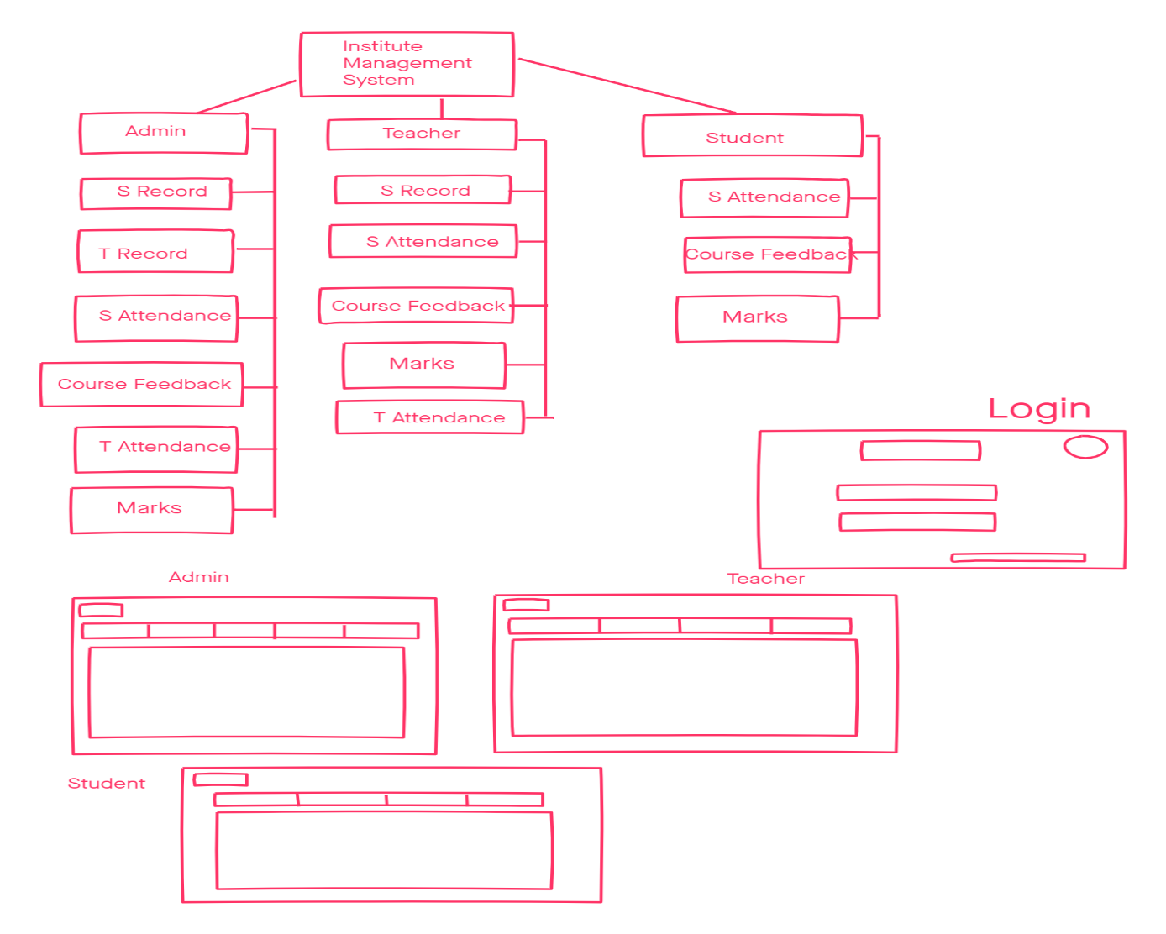

* **Existing System**

FLEX Portal, Student Profile System of Bahria and IBA, Management System of different schools, colleges and universities and also coaching centers and different institutes.

* **Salient Feature**

Classes, Objects, Input box , Images , Logo, GridView, Functions, Strings, Array

* **Problem Statement**

In many institutions it is very difficult to maintain student data and due to some reason it’s very almost impossible to check information about the student.Also record of teachers, marks of student and course feedback.

* **Proposed Solution**

We want to create a system which can handle student and teacher information so that this difficulty could be removed.

* **Tools & Technologies**

Programming language: C-Sharp

Database: SQL

Framework: Visual Studio 19

Operating System: Windows 10, Windows 7

Approved Reject

**Teacher Signature: ____________________________**